MercadoPago – OpenCart 1.5.x

Installation instructions

Compatible with OpenCart 1.5.x

- Copy the folders "admin", "catalog" and “image” to the OpenCart root installation. Make sure to keep the OpenCart folders structure intact.

Set up MercadoPago OpenCart plugin

- On your store administration, go to extensions > payments > Mercado Pago 2.0 > click Install
- Again in extensions > payments > Mercado Pago 2.0 > click Edit - to Setup your MercadoPago account

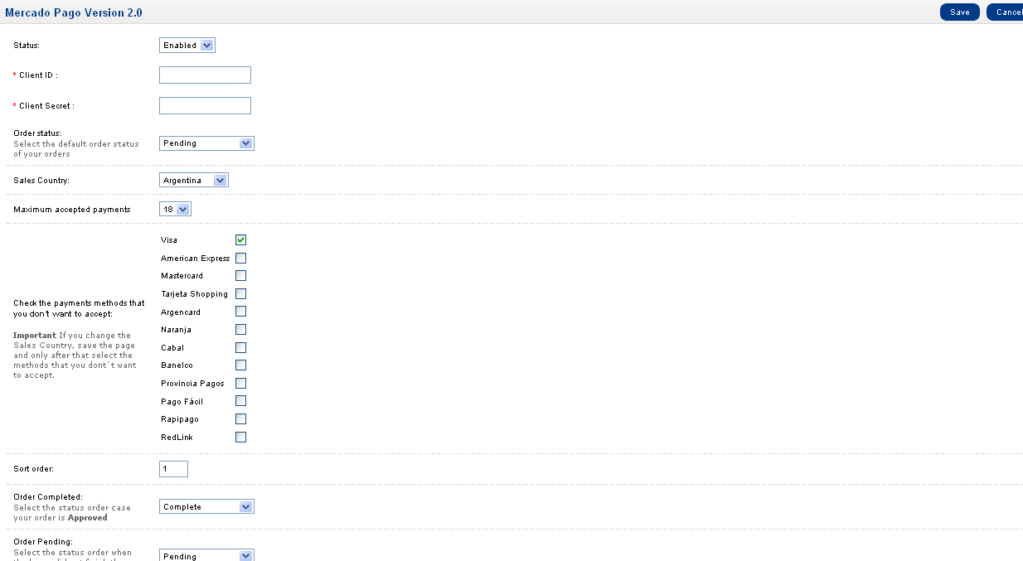

- Set your Country where your account was created and save config.
- Set your Client_id and Client_Secret. You could get in:
  - Argentina: https://www.mercadopago.com/mla/herramientas/aplicaciones
  - Brazil: https://www.mercadopago.com/mlb/ferramentas/aplicacoes

- Note: If you change the Country where your account was created you need save config to refresh the excluded payment methods.

Sync your backoffice with MercadoPago (IPN)

- Go to MercadoPago IPN admin page:
  - Argentina: https://www.mercadopago.com/mla/herramientas/notificaciones
  - Brazil: https://www.mercadopago.com/mlb/ferramentas/notificacoes

- Enter the URL as follow [yourstoreaddrees.com]/index.php?route=payment/mercadopago2/retorno/

